S.No | Inputs |  |  |  | Outcomes
 | Laser Power  P_{LZ} | Scanning Speed  S_{SP} | Number of passes  P_{C} | Laser Frequency  F_{LZ} | Surface waviness  S_{W} | Material Vaporization rate  MV_{R} | Heat affected zone  HA_{Z}
 | W | (mm/min) | no unit | (kHz) | (µm) | (mm³/sec) | (µm)
1 | 8.5 | 280 | 24 | 48 | 6.07 | 100.71 | 90.05
2 | 6.5 | 360 | 12 | 18 | 4.01 | 74.77 | 71.88
3 | 10.5 | 200 | 36 | 18 | 6.75 | 119.88 | 102.71
4 | 6.5 | 360 | 36 | 58 | 5.1 | 79.11 | 85.07
5 | 6.5 | 200 | 12 | 58 | 6.01 | 93.27 | 89.82
6 | 8.5 | 280 | 18 | 38 | 5.9 | 99.84 | 88.42
7 | 10.5 | 200 | 12 | 18 | 6.05 | 117.2 | 89.89
8 | 8.5 | 320 | 24 | 38 | 5.66 | 95.14 | 88.12
9 | 6.5 | 360 | 12 | 58 | 4.13 | 66.76 | 74.46
10 | 10.5 | 360 | 36 | 58 | 5.23 | 82.97 | 85.36
11 | 8.5 | 280 | 30 | 38 | 6.26 | 110.85 | 93.12
12 | 10.5 | 200 | 36 | 58 | 7.32 | 115.82 | 108.08
13 | 10.5 | 360 | 36 | 18 | 4.9 | 90.99 | 82.88
14 | 6.5 | 200 | 12 | 18 | 5.6 | 102.68 | 86.30
15 | 8.5 | 240 | 24 | 38 | 6.44 | 115.36 | 93.28
16 | 7.5 | 280 | 24 | 38 | 6.02 | 102.48 | 89.51
17 | 10.5 | 360 | 12 | 18 | 4.33 | 86.1 | 75.64
18 | 8.5 | 280 | 24 | 28 | 5.94 | 107.2 | 89.40
19 | 9.5 | 280 | 24 | 38 | 6.21 | 108.79 | 90.81
20 | 6.5 | 200 | 36 | 58 | 7.1 | 122.52 | 106.40
21 | 6.5 | 360 | 36 | 18 | 4.69 | 87.58 | 78.76
22 | 6.5 | 200 | 36 | 18 | 6.63 | 114.14 | 94.76
23 | 10.5 | 200 | 12 | 58 | 6.43 | 107 | 94.59
24 | 10.5 | 360 | 12 | 58 | 4.69 | 78.57 | 81.59

Output | Ridge Hyper  parameter | Ridge R² | RF Hyper  parameter | RF R² | XGB Hyperparameter | XGB R² | NN Hyperparameter | NN R²
surface Waviness | {'alpha': 1, } | 0.918 | {n_estimators=100, max_depth=10} | 0.981 | {n_estimators=100, max_depth=5, learning_rate=0.05} | 0.999 | {'hidden_layer_sizes': architecture=(6,4,3), alpha=0.001, learning_rate=0.0} | 0.979
MVR | {'alpha': 1, } | 0.866 | {'n_estimators':100,  'max_depth':10} | 0.970 | {'n_estimators':100,  'max_depth':5,  'learning_rate':0.05,  'subsample':0.8} | 0.997 | {'hidden_layer_sizes:'  architecture=(8,5,4), alpha=0.001, learning_rate=0.01} | 0.887
Heat Affected Zone | {'alpha': 1, } | 0.941 | {'n_estimators':100  ,'max_depth':10} | 0.974 | {'n_estimators':100,  'max_depth':5  ,'learning_rate':0.05,  'subsample':0.8} | 0.998 | {'hidden_layer_sizes': architecture=(6,4,2), alpha=0.001, learning_rate=0.01} | 0.744
Hyperparameter

Ensemble Performance Summary
Ensemble Model Performance Summary
Target | RMSE | MAE | R²
Surface Waviness | 0.0668 | 0.0561 | 0.9944
MVR | 1.3266 | 1.0954 | 0.9925
Heat Affected Zone | 0.5858 | 0.5000 | 0.9956

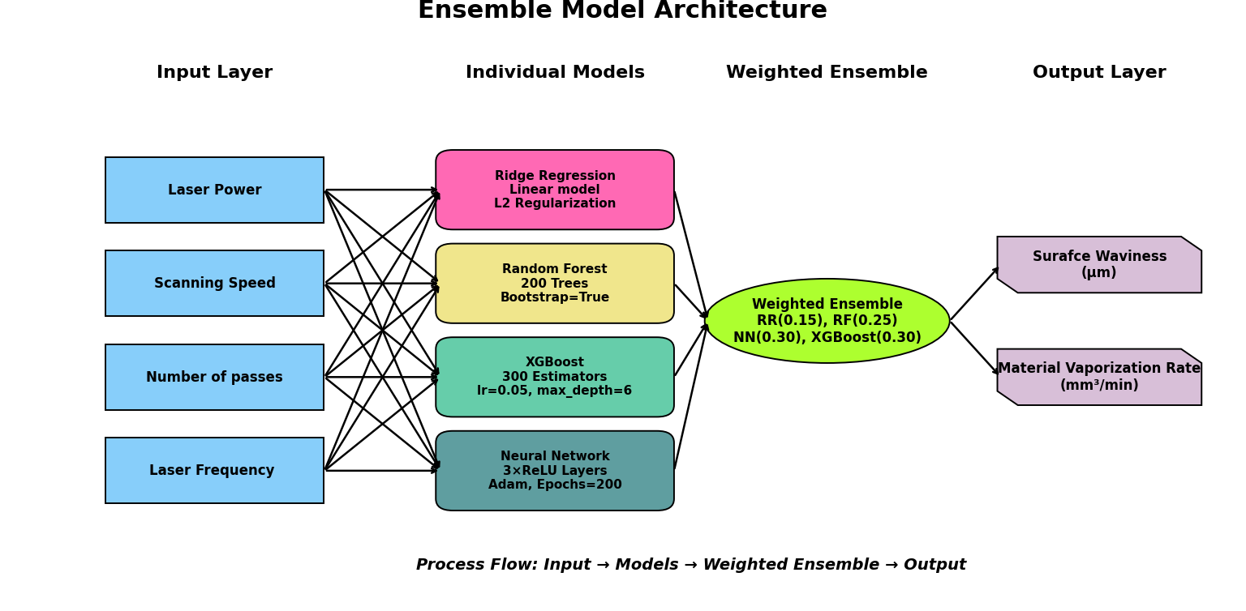

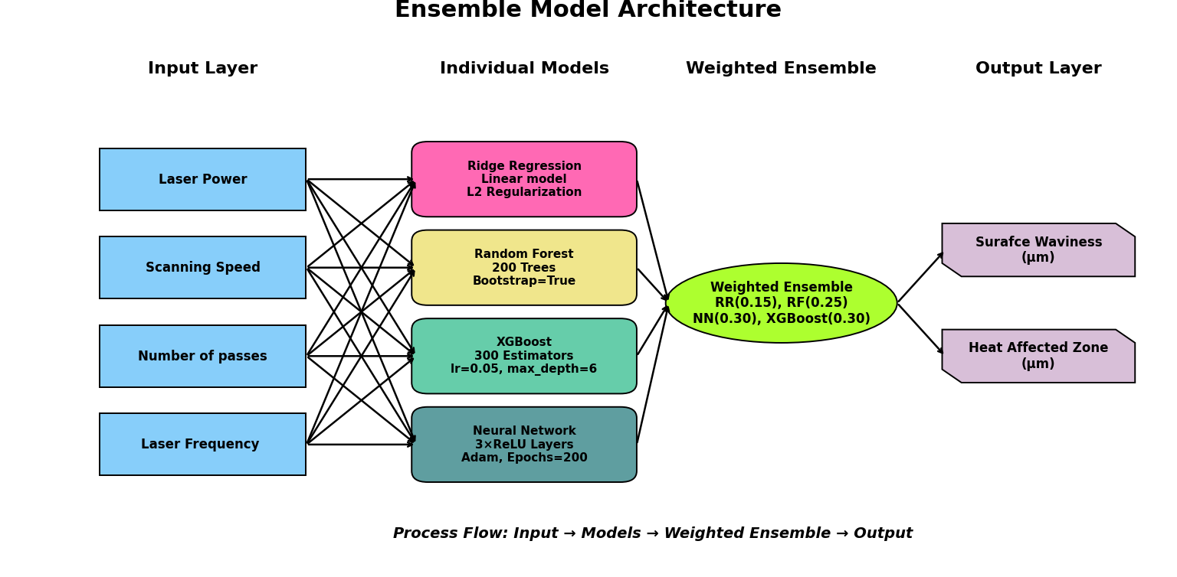
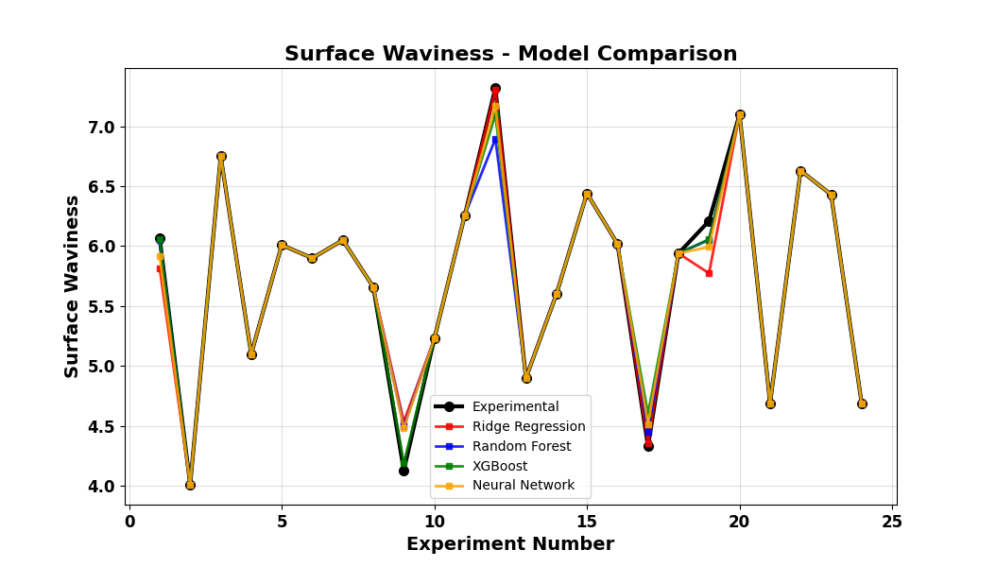
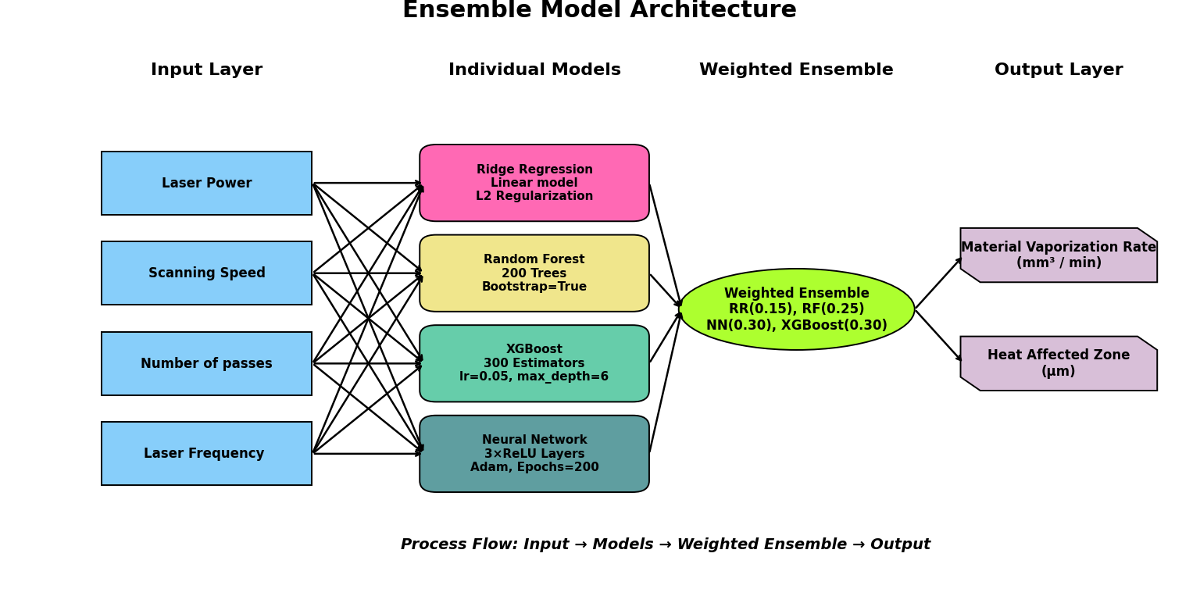
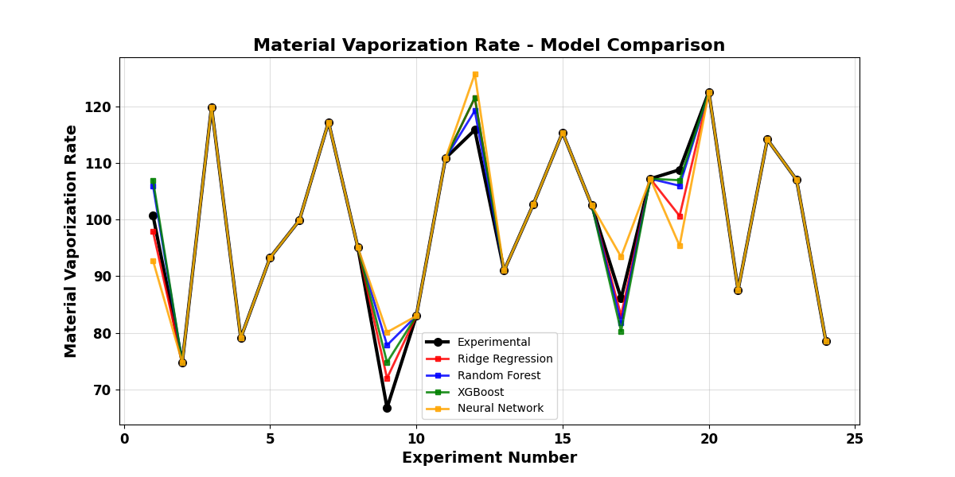

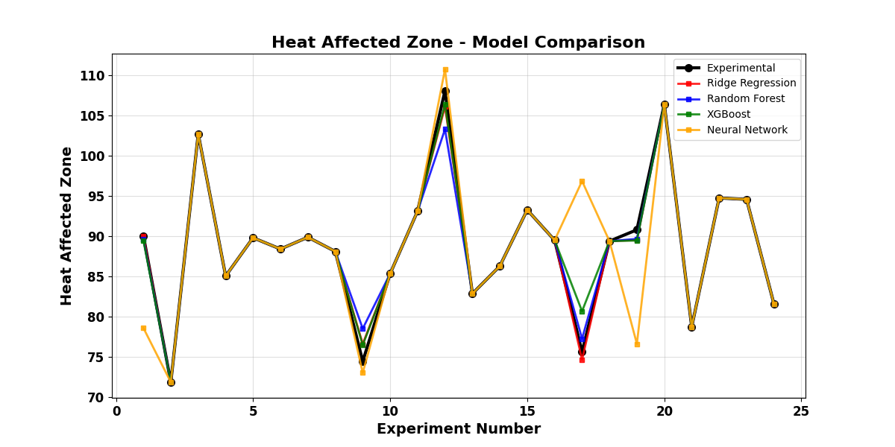

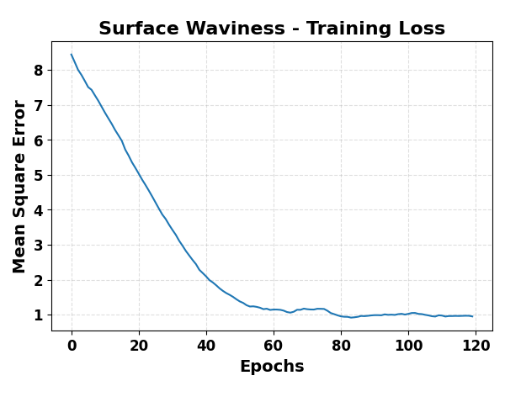
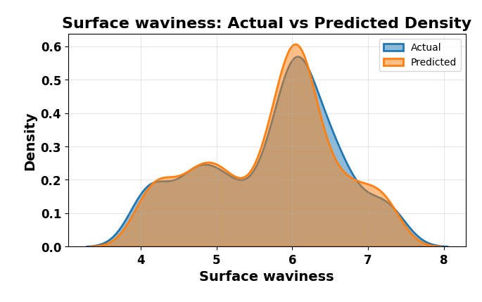
SURFACE WAVINESS

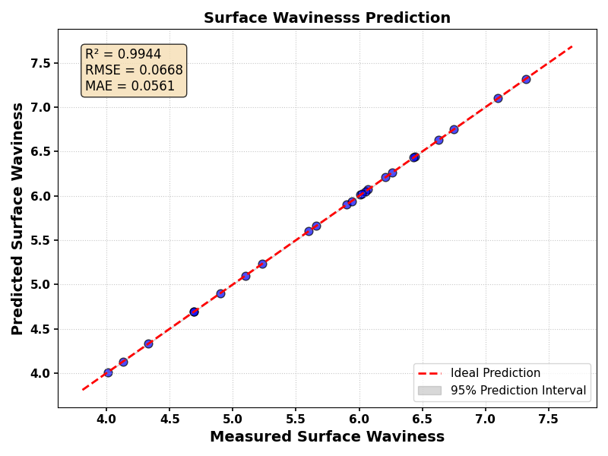
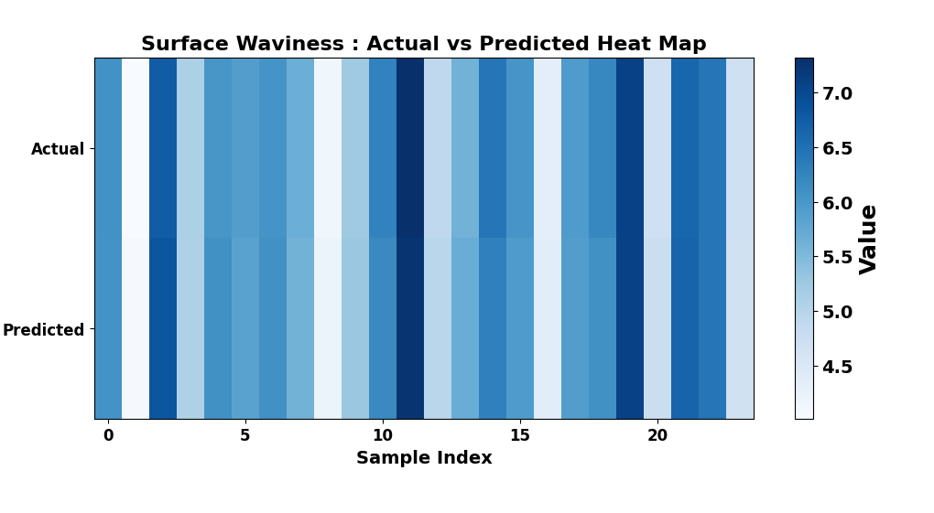
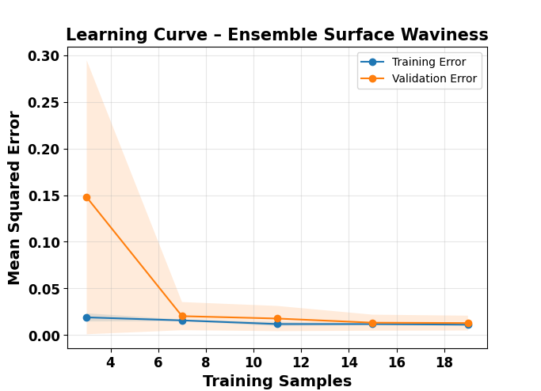
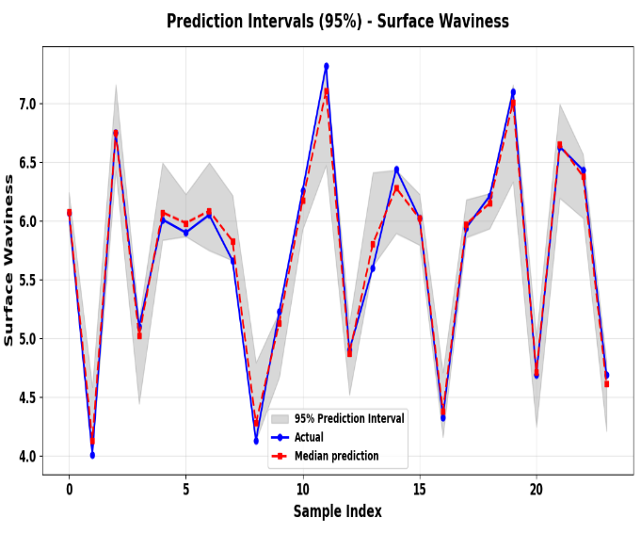

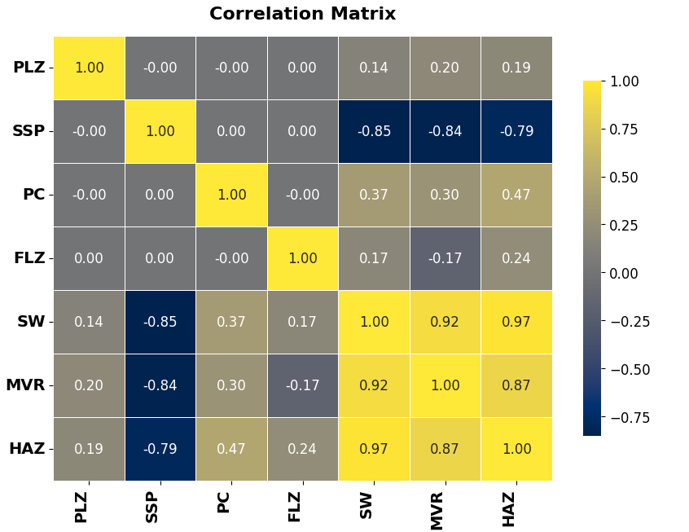
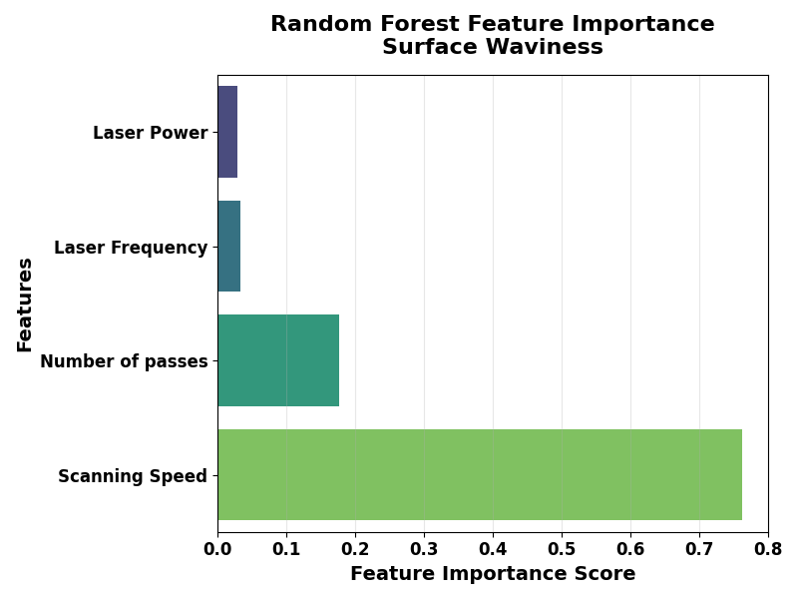
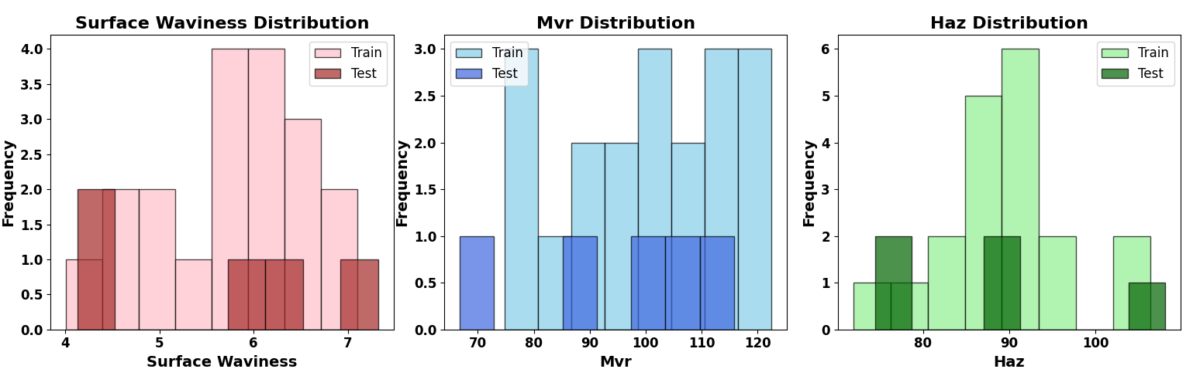
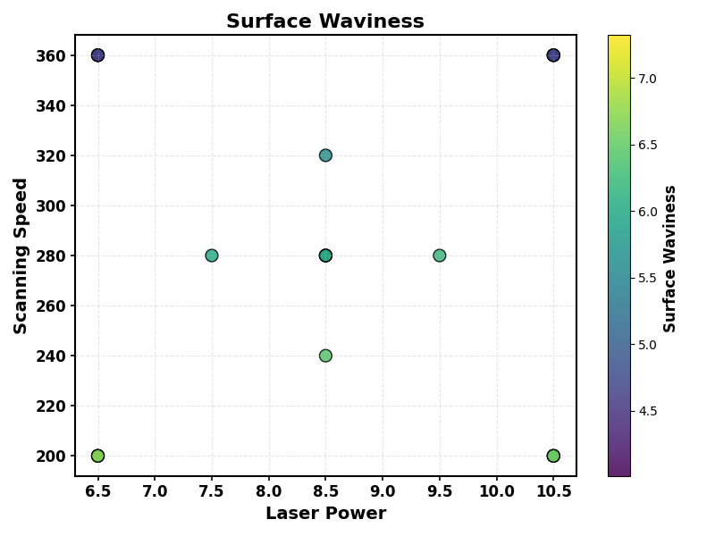
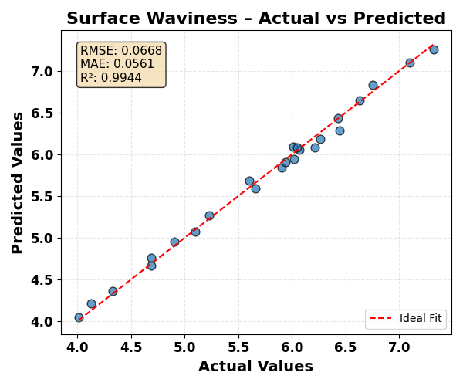

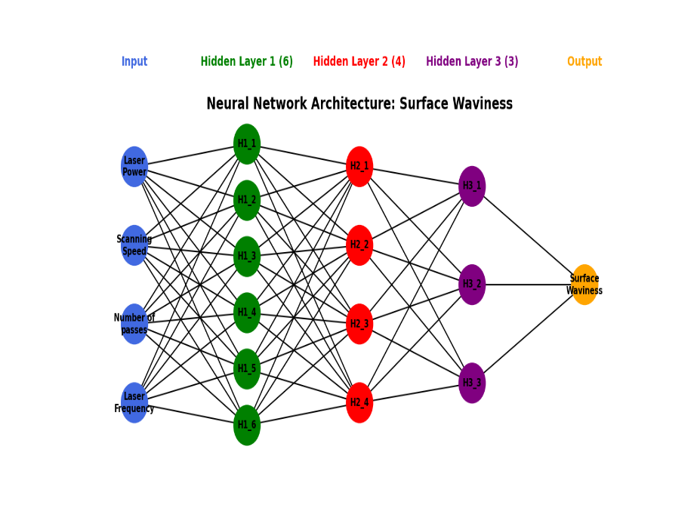

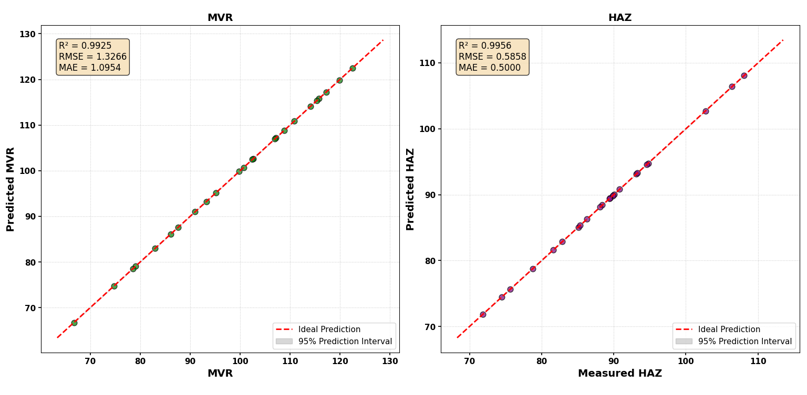
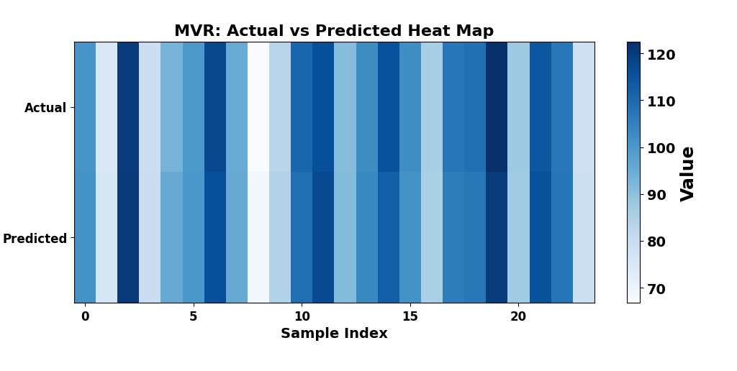

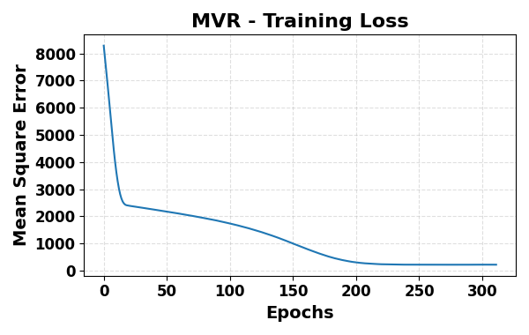
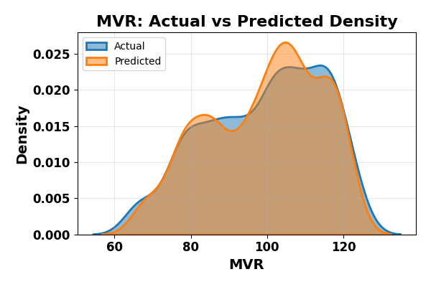
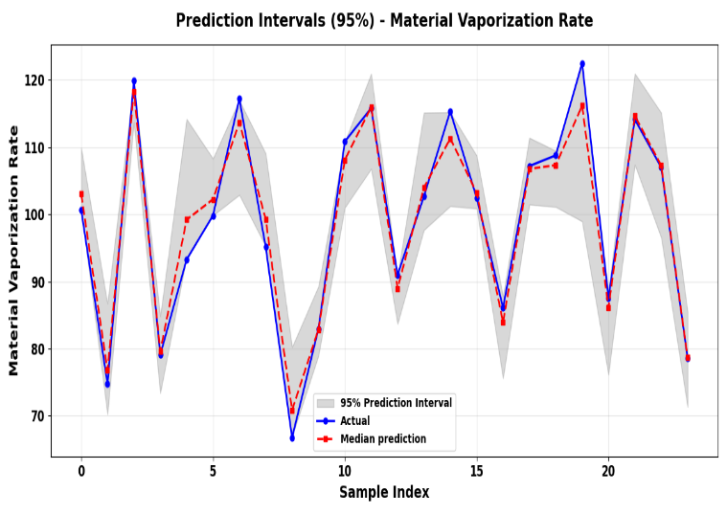
MVR

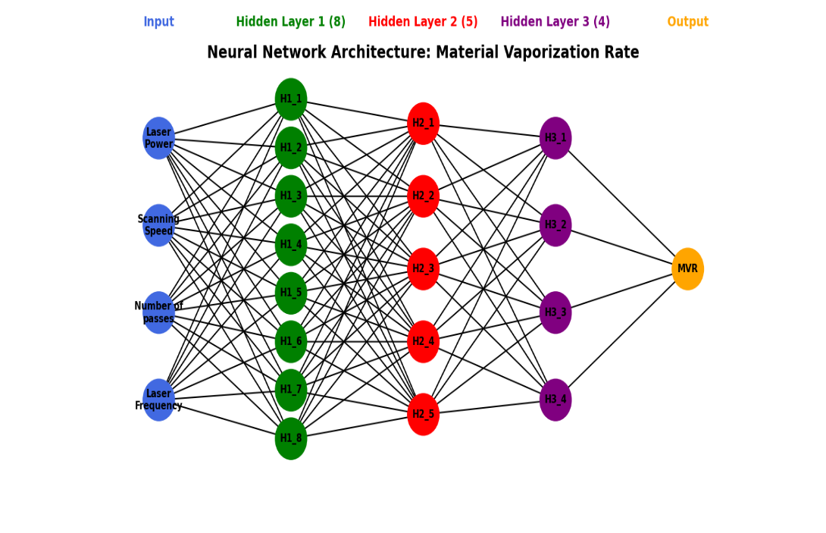
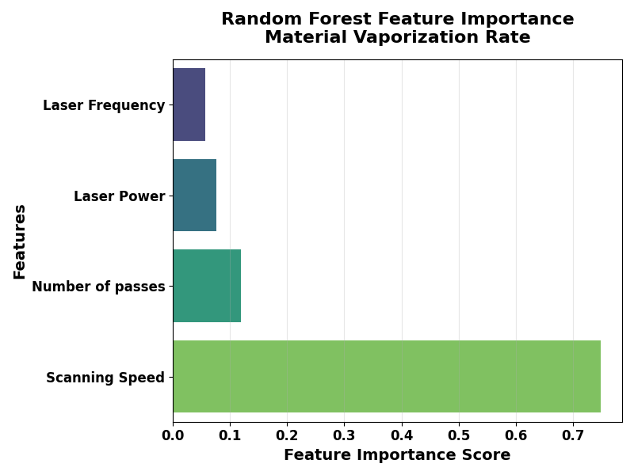
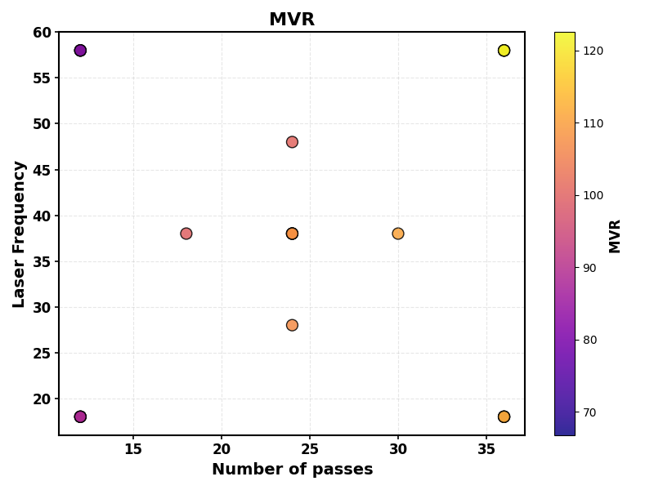
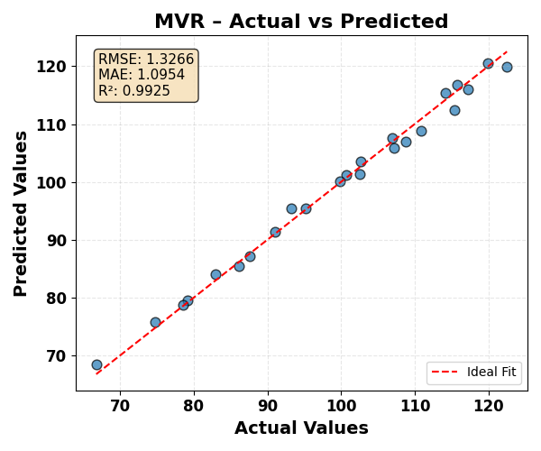

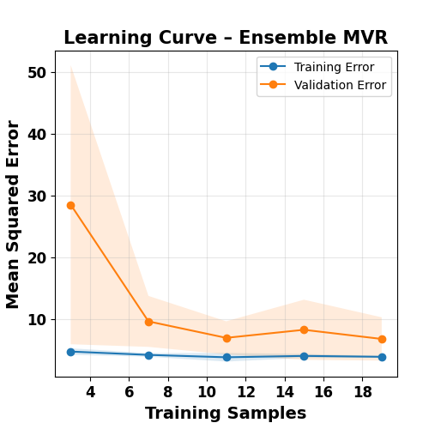


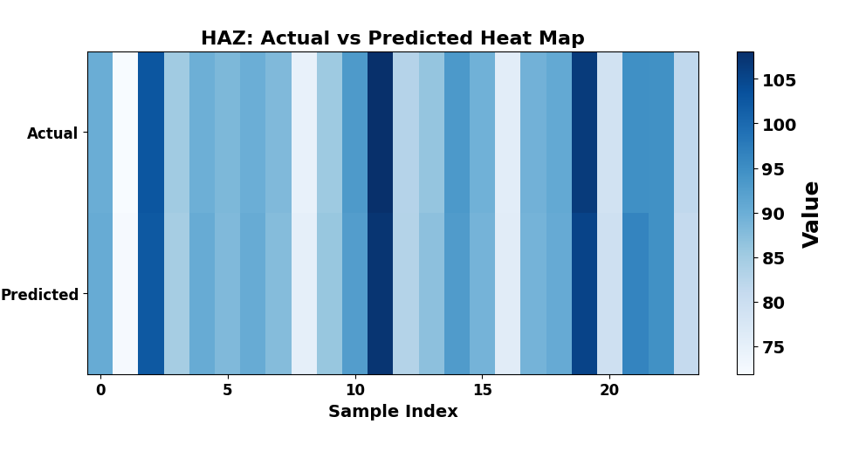

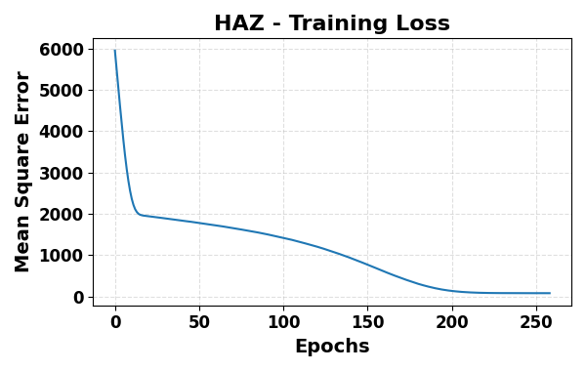
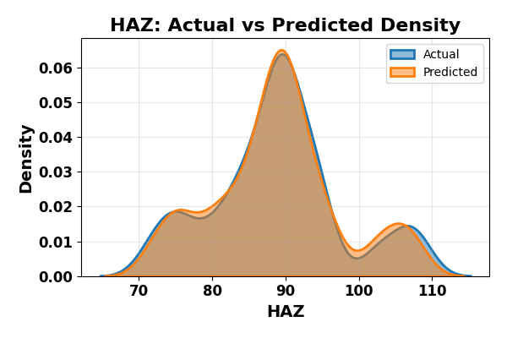
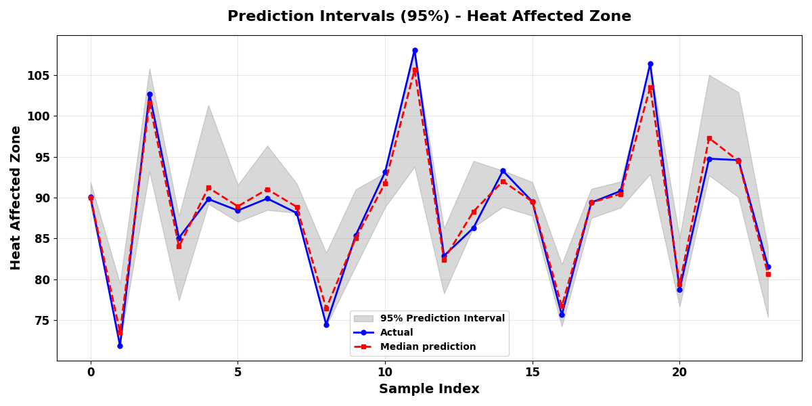
HAZ

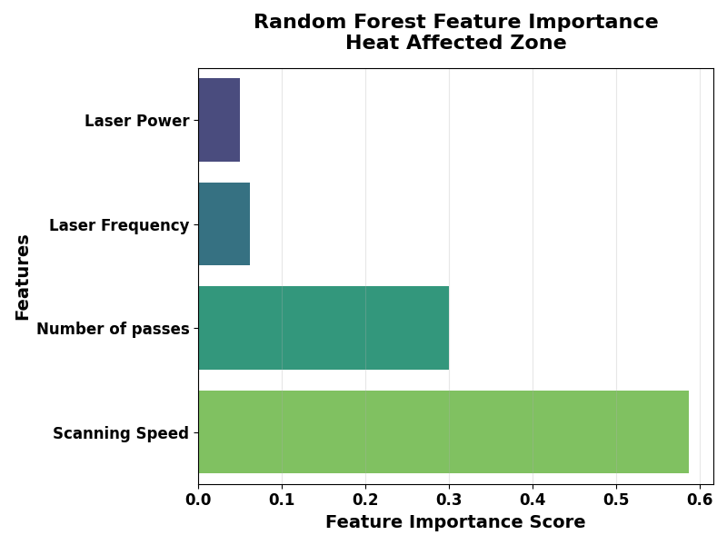
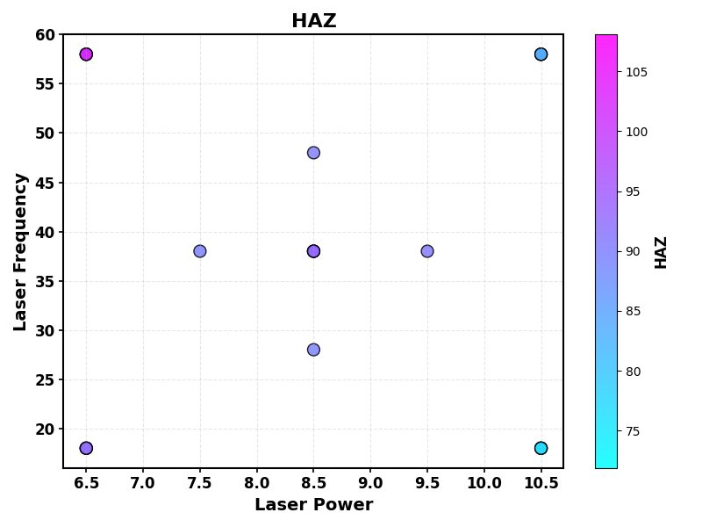
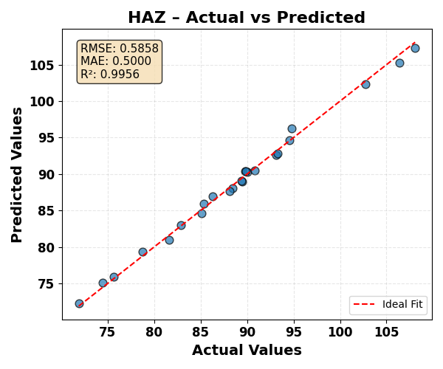
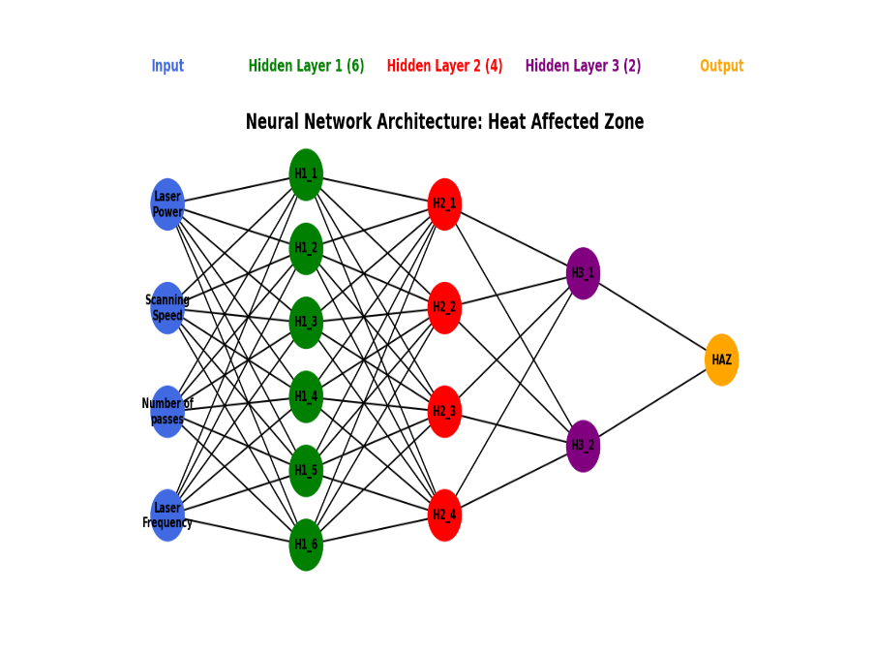
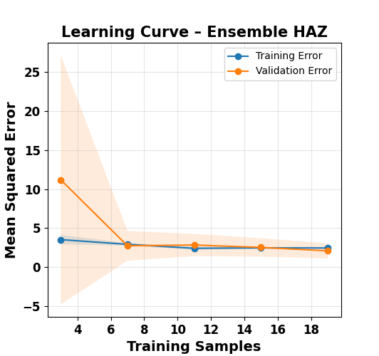


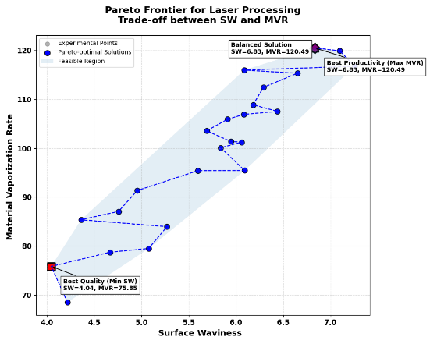
Table 3: Optimal Laser Process Parameter
Parameter | Min SW | Min HAZ | Balanced
Laser Power | 6.50 | 6.50 | 6.50
Scanning Speed | 360.00 | 360.00 | 360.00
Number of passes | 12.00 | 12.00 | 12.00
Laser Frequency | 18.00 | 18.00 | 18.00
Surface Waviness | 4.045 | 4.045 | 4.045
HAZ | 72.287 | 72.287 | 72.287
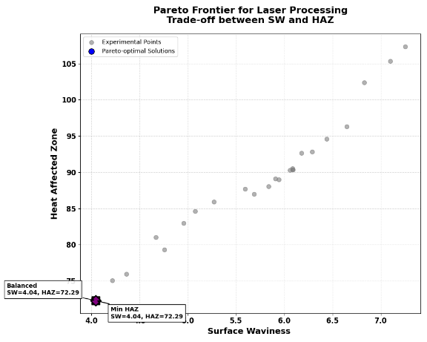

Table 3: Optimal Laser Process Parameter
Parameter | Min HAZ | Max MVR | Balanced
Laser Power | 6.50 | 6.50 | 10.50
Scanning Speed | 360.00 | 200.00 | 200.00
Number of passes | 12.00 | 36.00 | 12.00
Laser Frequency | 18.00 | 58.00 | 18.00
Heat Affected Zone | 72.287 | 102.351 | 90..342
MVR | 75.847 | 120.486 | 115.970
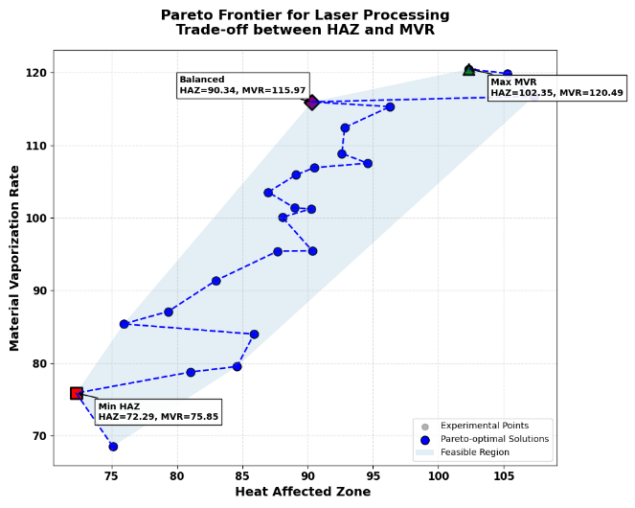
Table 3: Optimal Laser Process Parameter
Parameter | Min SW | Max MVR | Balanced
Laser Power | 6.50 | 10.50 | 10.50
Scanning Speed | 360.00 | 200.00 | 200.00
Number of passes | 12.00 | 36.00 | 36.00
Laser Frequency | 18.00 | 18.00 | 18.00
Surface Waviness | 4.045 | 120.486 | 120.486
MVR | 75.847 | 102.351 | 102.351

